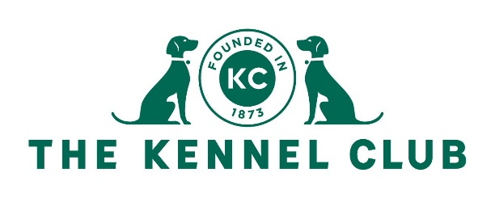

KENNEL CLUB WORKING TEST AT CAPESTHORNE
CARAVAN/CAMPING BOOKING FORM

NAME

Registration number and make of towing vehicle
Registration number of additional vehicles on pitch
Type of unit/
Make of caravan
Size of unit
Awning
Yes/No
Day of arrival

PLEASE RETURN TO KATE BROERS: ft.secretary@thekennelclub.org.uk

